Apollo Personalized Signature Template
The last email signature template that went out was scaled improperly, so most employees are currently using a template with our new logo that is distorted (squashed). See example here….
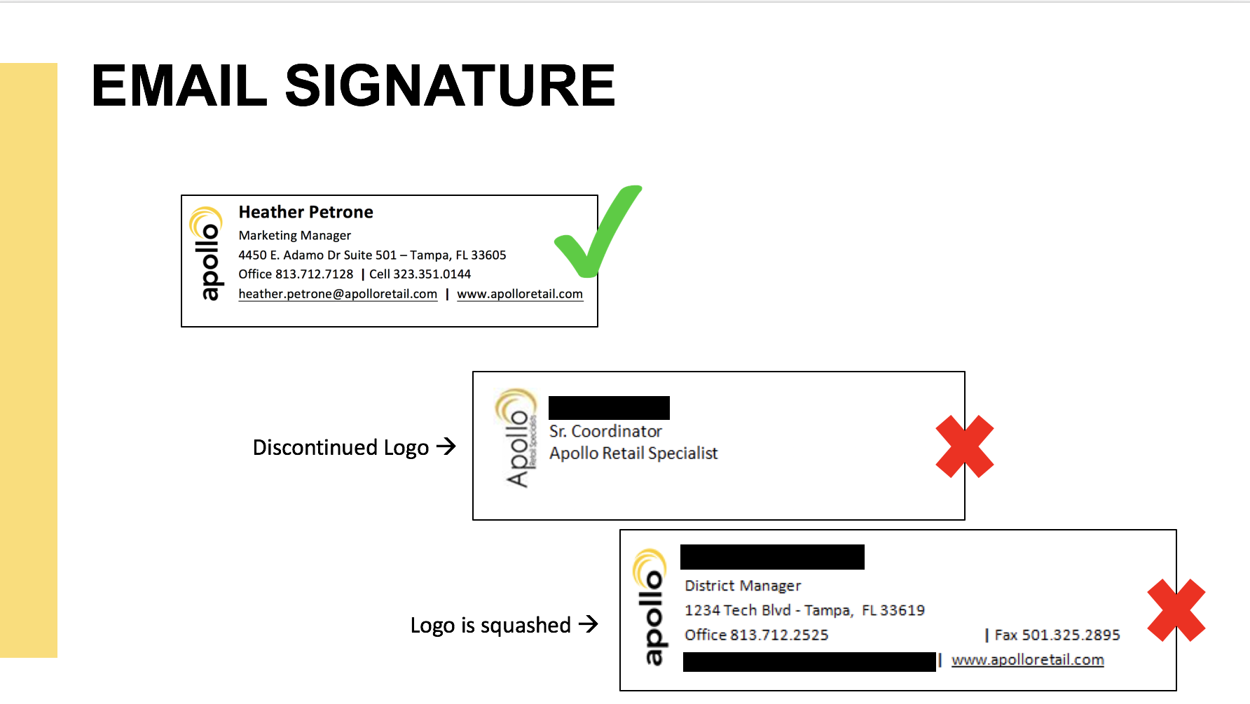

When using the template below, please DO NOT move or scale the logo or you could end up distorting!

Fill in your information in the template below – do not put your home address – use the address closest to you or leave blank. Right click on your email and edit the hyperlink. Hyperlink your email to the text as shown in the video. Remember to delete mailto: from your signature after you hyperlink. Once done, copy the item as shown in the video. You MUST use ARIAL font in Black for Email signature and default your email text to ARIAL as well.

First Last
Title
4450 E. Adamo Dr. Suite 501 – Tampa, FL 33605
Office 813.712.2525 | Cell XXX.XXX.XXXX
xxx.xxxxxxx@apolloretail.com | www.apolloretail.com

Then Go to Outlook>File>Options>Mail>Signature. Paste your signature image into the signature area. Right click on the clipboard icon and select “Use destination formatting” as shown in the video.
